**Defining Receiver Success and**

**Identifying Most Effective Route Combinations**

**Introduction**

When tasked with identifying the NFL’s most effective receiver route combinations, several questions must be considered. Chief among them is what “effective” means, in terms of an offensive play call. The easy solution is to look toward well-understood and commonly-repeated statistical measures, such as yards gained, touchdowns thrown, and expected points added (EPA). However, all of these measures have one key drawback: they all rely on external factors, outside the scope of a receiver and his route. For example, using a measure like the play’s resulting yardage gain puts an enormous amount of weight on the quarterback’s shoulders. Did the quarterback choose the correct receiver to target? Did he have ample time in the pocket to set his feet for the throw? Is he as accurate a passer on a post route as he is on a quick out? Even outside the quarterback, yardage depends on other external factors, such as the receiver’s catching skill and the weather conditions. In order to answer the true spirit of the question, we need to strip each play of these external factors, leaving only the route and the receiver’s effectiveness while running it.

We define Receiver Score as a simple combination of two concepts: the “openness” of the receiver, and the potential game impact of a completion. En route to this calculation, several challenges had to be overcome. Firstly, the NFL’s player tracking data does not contain a label for each route run by a receiver. Therefore, our first project was to develop a *scalable* method of identifying route types. Rather than watch animations or game film to manually label the specific routes used in this analysis, we decided to invent an approach that can be applied instantly to any quantity of player tracking data. Secondly, we implemented a method to quantify the spatial characteristics of receivers and defenders, in order to view their routes and coverages through a data-focused lens. Lastly, we constructed a flexible solution that can be executed over any number of NFL games and used to evaluate receiver effectiveness at multiple levels of analysis, including Play, Player, Route Type, and Route Combination. In this report, we will answer the following questions:

1. What constitutes a successful outcome for receivers?
2. How can we evaluate the receiver traits that determine the success of a route?
3. What are the most effective routes and route combinations, overall?
4. What are the most effective routes and route combinations against four of the most common defensive schemes?

**Methods**

*Route Identification*

Like with any project involving large amounts of information, a detailed understanding of the data being used is a must. For this analysis project we are using data provided by NFL Football Operations, which is described as a combination of traditional and Next Gen Stats. We have made the decision to not use any additional data sources at this time. The data provided is a collection of spatial data that tracks player movement during a game, player identification detail, and play result information. With this amount of information, nearly every detail of a game is covered.

A great deal of time was taken to ensure that we fully understand the type of data we are working with and the possibilities it possesses. To begin our analysis, we start by filtering the data to passing plays resulting in a completion, incompletion, or interception. By doing this, we can focus on those play types where full routes are run, and where the play could not be affected by a quarterback sack. Additionally, we remove any plays involving a penalty. We do this because a penalty may have an unknown effect on a receiver’s route. The receiver may have been the subject of a holding penalty, thus distorting the results of a play that, in the end, did not count. Plays like the shovel pass are also ignored in the analysis, due to the quick release and questionable existence of a route. With the quick nature of a shovel pass, there is little time in the play to determine the route’s quality.

One of the first variables we need to identify for this project is the specific route type that each receiver runs during each play. This could be done by watching each play carefully and manually classifying each route, but with nearly 6,000 plays in this dataset, that equates to over 22,000 routes. Instead, we need to consider how to identify a route programmatically, and in a way that is simple and efficient to implement. Routes were defined by calculating each receiver’s angular change during the play, as described in the figures below.

***Figure 1***

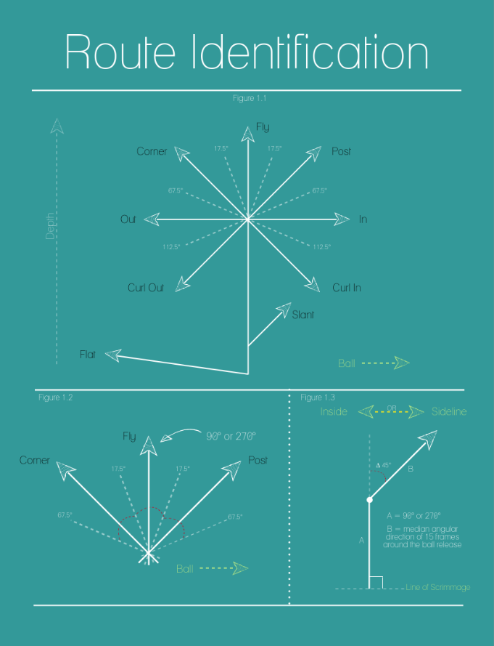

Consider a traditional corner route. In its simplest form, the corner is a two-part route, consisting of an initial direction from the line of scrimmage with a change in direction towards the sideline at ~ 45°. In fact, eight of the nine routes in the standard route tree (*Figure 1.1*) consist of an initial direction A and a final direction B (*Figure 1.3*). The resulting change in direction can be used to programmatically determine a route.

Now that we understand how to programmatically determine a route, we need to apply this knowledge to the analysis. Using the spatial data provided by the NFL, we first identify which direction the team is moving (90° or 270°). Secondly, we determine at which frames the ball is snapped and thrown. With these two points in time, we can establish directions A and B of a route (see *Figure 1.3*). The initial direction A is simply defined by the direction the offense is facing. For simplicity, we use the median angular direction over a specific subset of frames to calculate the final direction B. The frames used to determine the median are the five frames before and ten frames after the ball is released. The intent here is to capture a moment between the receiver changing direction and the ball arriving at its target. Additionally, once the ball has been thrown, all focus shifts to the intended target. Cutting off the analysis shortly after the ball is released mitigates the statistical noise created by this behavior. We have also accounted for situations where the angular change during a route crosses 0°, resulting in the true angle change completed by the receiver.

With the route angle now determined, we need to decipher the difference between routes with similar changes in angular direction. For instance, a post route and corner route (see *Figure 1.1*) have identical changes in angular direction (~45°). The only difference is that a corner route turns towards the sideline and a post route turns toward the inside of the field. With this understanding, we take into account each player’s side of the formation (right or left), initial direction (90° or 270°), and angular change to identify the route type.

***Figure 2***

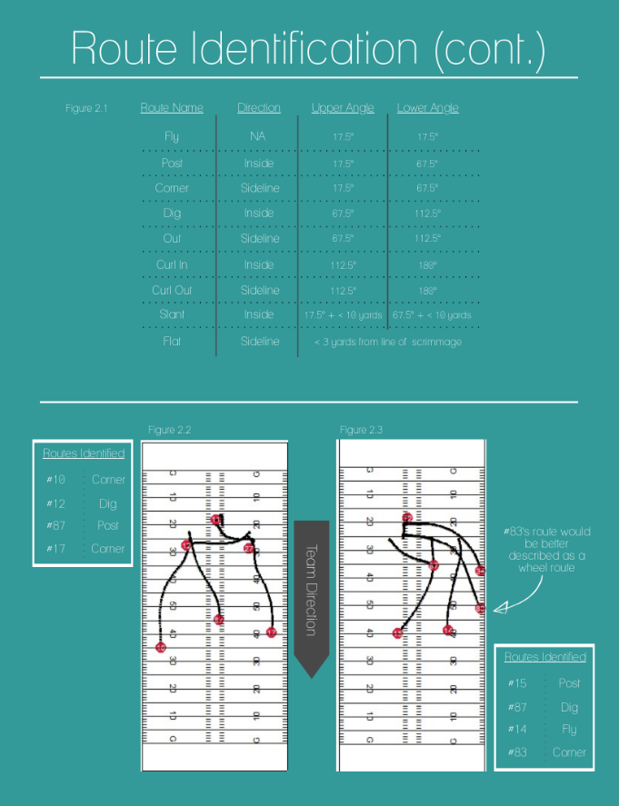

With the pre-processing completed, we can finally assign route names to each route run during a play. For simplicity, we are only looking at the wide receiver and tight end positions and classifying them to one of the nine possible route types shown in *Figure 1.1*.

For route like slants and flats, a distance metric is used to differentiate these shorter routes from similar routes further down the field. Since the slant route’s change in angular direction is nearly identical to that of a post route, we restrict slant routes to within 10 yards downfield. A flat route is classified as any route toward the sideline where the receiver is less than three yards from the line of scrimmage at the time the ball is thrown.

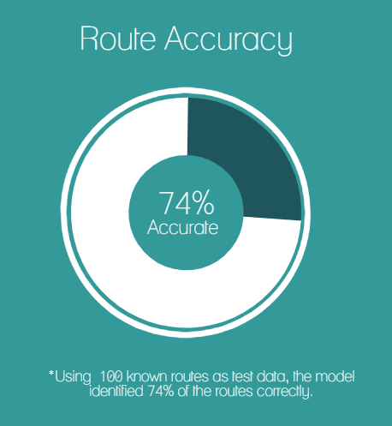

Overall, the model performs very well in classifying routes. When we looked at a sample of 100 pre-identified routes, we found that the model classifies the routes with an accuracy of 74%. Given the simplicity of the logical model and the complexity of route running, it is exciting to see such a strong accuracy metric. However, this means that 26% of routes were labeled incorrectly. These include routes with double moves and “lazy” routes that take time to develop, like the wheel route. We see an example of this in play 68 (*Figure 2.3*), where #83 runs a wheel route that our method classifies as a corner route. We address the potential improvements to this identification system in the Future Work section. We believe there are ways to address these deficiencies, if time allows.

*Receiver Success*

Our definition of a receiver’s success is based on two concepts: the receiver’s “openness” and the potential game impact of a successful completion. Here, openness can be strictly defined as the likelihood of a completion, given a perfect pass at the perfect time by the quarterback, as well as perfect catching ability by the receiver. Although we recognize that football is an inherently imperfect sport, we must remove the noise of players’ imperfections in order to evaluate the route itself. However, our definition does still depend on a receiver’s route-running skills, like acceleration, elusiveness, top-end speed, and ability to find holes in the defense. We address this idea in our Future Work section.

The two quantities that constitute openness are Separation and Position. Separation is defined as the number of yards between a receiver and his closest defender. We focus on only the nearest defender, because typically, only one defender can make a play on the ball at a time. While double coverage may increase the likelihood of a defender being in position to defend the pass, we argue that the second-closest defender does not significantly lower the probability of a completion when the quarterback has thrown a perfect pass. Position describes the defender’s relative position to the receiver and quarterback. We quantified this concept by dividing the area around a receiver into four quadrants, then rating each quadrant “Ideal”, “Good”, or “Bad” for the receiver. Of course, this entirely depends on the type of route being run, (as well as the position of the quarterback, but we assume he stays in the pocket). Three examples of Position ratings can be seen in *Figure 3*, with the entire breakdown included in the Appendix.

***Figure 3***

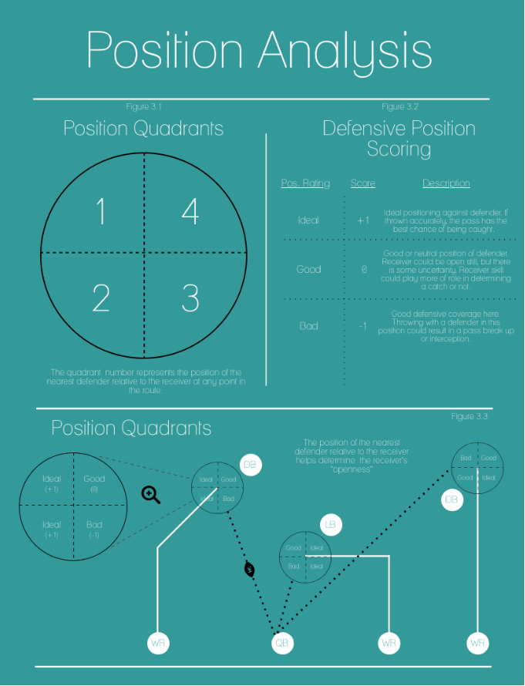

Potential game impact is a crucial piece to the Receiver Success Score, for one simple reason: if openness remains equal, a deeper route is a greater success than a more shallow route. For this analysis, game impact is derived from the receiver’s depth downfield, quantified in two pieces. Firstly, Depth is simply the number of yards downfield from the line of scrimmage. However, since this quantity’s effect would change according to field position, we limited Depth to 25 yards, a common definition of a “Big Play” in the passing game. Secondly, we incorporated a simple First Down measure. The simple truth is that not all yards are created equally. For example, on a 3rd and 10 play, there is a vast difference between gains of 9 yards and 10 yards. However, 10 yards and 11 yards would be approximately equivalent in terms of game impact. For this reason, we give a bonus to receivers who pass the first down marker, (or the goal line, in goal-to-go situations).

Since our goal is to create the success metric itself, independent of other common football statistics, standard supervised statistical models are not helpful. Instead, we aim to create a simple, interpretable metric that can be easily explained in football terms. The Receiver Score is simply an additive model with adjustable weights applied to each of the four components:

* **Separation**: yards between receiver and nearest defender
$S= 1 point per yard$

* **Position**: rating of nearest defender’s position relative to receiver and quarterback
$P=\left\{\begin{matrix}2 points, "Ideal Position" \\ 0 points, "Good Position" \\ -2 points, "Bad Position"\end{matrix}\right.$

* **Depth**: yards downfield from line of scrimmage
$D=0.1 points per yard, up to 2.5 points$

* **First Down**: whether or not receiver passed first down marker

$FD= \left\{\begin{matrix}1 point, receiver passed first down marker \\ 0 points, receiver did not pass first down marker \end{matrix}\right.$

$$Receiver Score=S+P+D+FD$$

This score is calculated at every frame for every receiver in a play, (excluding running backs). In order to determine a single score for each route, we could employ multiple aggregation functions, each with different interpretations. For example, a route’s *mean* or *median* Receiver Score would evaluate a route’s typical effectiveness, useful when incorporating imperfect quarterback play. A route’s *minimum* Receiver Score would give us the floor of each route’s ability to succeed. For the purposes of evaluating routes alone, given perfect quarterback play, we elected to use the *maximum* Receiver Score on each route, interpreted as the maximum potential for success. This quantity is called the **Route Score**. See *Figure 4* for four Route Score examples from the Chiefs/Patriots game in Week 1 of 2017.

***Figure 4***

*Figure 4.4*

*Figure 4.3*

*Figure 4.2*

*Figure 4.1*

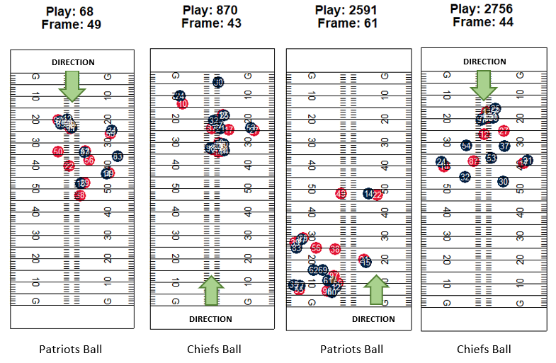

In Play 68, Dwayne Allen (#83) has run a wheel route to break open down the sideline. This results in an excellent score of 10.8, matching our intuition as to the route’s effectiveness, (the other players’ Route Scores on this play were 6.9, 5.8, and 5.8). However, although Tom Brady (#12) made the correct targeting decision, Allen was unable to catch the pass. This play results in 0 yards gained and presumably a negative EPA. This is why our Route Score metric only takes into consideration the receiver’s route, eliminating influence from other factors like quarterback decisions and receiver catching ability. In Play 870, however, the quarterback is able to identify an excellent target who did not earn the play’s top Route Score. At frame 43, Alex Smith (#11) threw to Chris Conley (#17), who collected yards after the catch (YAC) for an 18-yard gain. In this example, Tyreek Hill (#10) actually earned the highest Route Score, due to soft coverage at the beginning of the play. This extra separation gave Hill a higher calculated chance for success than Conley, even though Conley had a greater opportunity for YAC. As outlined in the Future Work section, this success metric could benefit from the incorporation of player velocities and potential YAC.

Play 2591 is an excellent example of external factors affecting the play result, while the Route Scores give a more objective view of route success. When Brady is pressured by the formidable Justin Houston (#50), he lofts a pass in the direction of Allen and Rob Gronkowski (#87) that falls incomplete. If Brady’s offensive line had given him more time in the pocket, he may have found Brandin Cooks (#14) running past the safety on a deep post route. Cooks scored 9.1 points on this play by creating respectable separation while earning the maximum depth points and gaining a favorable position on his nearest defender. In contrast, Play 2756 shows Smith looking for the big play as Hill blazes past his unfortunate defender, 2018 All-Pro cornerback Stephon Gilmore (#24), for a Route Score of 7.3. However, while Hill had over 9 yards of separation by the time the ball arrived downfield, he had only 2.6 yards of space when Smith released the ball. For this reason, Hill was only the third-highest scorer on this play, behind Travis Kelce (#87) and Albert Wilson (#12). At frame 44, Kelce scored a stellar 11.5 points, due to over 7 yards of separation, ideal position on his defender, and a deep route. The data would have chosen a pass to Kelce for a probable 25-yard gain, but Smith knew Hill’s speed would overwhelm Gilmore’s coverage and create massive YAC. Once again, potential yards after the catch would be a useful addition to the receiver success metric.

Much like the Route Score, when evaluating a combination of routes, we find the maximum score across all routes, interpreted as that play’s maximum potential for success. This is called the **Route Combination Score**. With these two scores, we can aggregate to several interesting levels of analysis:

* **Route Type**: mean Route Score per route type
* **Player/Route Type**: mean Route Score per player/route type
* **Player**: mean Route Score per player
* **Route Combination**: mean Route Combination Score per route combination
* **Route Combination/Defensive Scheme**: mean Route Combination Score per route combination and defensive scheme

**Results**

We will present three results in this report, all in the form of ranked lists. In order to qualify for presentation, a particular group needs at least five plays run within the period of analysis. While this analysis did contain a number of four-player route combinations, the data was too sparse to generate any meaningful conclusions.

***Table 1: Ranking of Route Types, Overall***

|  |  |  |  |  |  |  |
| --- | --- | --- | --- | --- | --- | --- |
| **Route Type** | **Sample Size** | **Separation** | **Position** | **Depth** | **First Down** | **Overall** |
| Curl Out | 209 | 4.7 | 1.8 | 0.9 | 0.5 | 7.9 |
| Post | 1760 | 4.4 | 1.6 | 0.9 | 0.6 | 7.5 |
| Dig | 2219 | 4.2 | 1.7 | 0.4 | 0.2 | 6.7 |
| Corner | 4374 | 3.9 | 1.8 | 0.6 | 0.3 | 6.6 |
| Curl In | 187 | 4.2 | 1.2 | 0.7 | 0.4 | 6.6 |
| Out | 1001 | 4.1 | 1.6 | 0.5 | 0.3 | 6.5 |
| Slant | 3686 | 3.6 | 1.6 | 0.3 | 0.2 | 5.6 |
| Fly | 5171 | 4 | 0.1 | 0.6 | 0.3 | 5 |
| Flat | 4275 | 3.8 | -0.5 | -0.1 | 0 | 3.2 |

The ranking of individual route types in *Table 1* portrays how well each route performs, independent of defensive scheme or other receivers’ routes. We see the top overall scores from Curl Out and Post routes, which are also reflected in the route combination results below. Because the overall score is calculated as a sum of four components, it is straightforward to use each component score to gain insight into a route’s strengths and weaknesses. For example, the Dig route scores well on Separation and Position, but its typical depth hurts its score, compared to the top two routes. The Fly route is another interesting example, with an unexpectedly mediocre Depth value. This is due to the data limitations explained in the Methods section. Because route definitions must be cut off at the time of ball release, the slower-developing routes suffer from quick-release plays. In this case, a play may have incorporated a Post, Corner, Dig, Out, or Curl route but was cut off by a quick pass from the quarterback while the receiver was still running downfield. This results in a Fly route with a shorter Depth than expected.

***Table 2: Ranking of Route Combinations, (min. 5 plays)***

***(Top 3 shown for each Player Count)***

|  |  |  |  |
| --- | --- | --- | --- |
| **Player Count** | **Route Combo** | **Sample Size** | **Score** |
| 1 | Curl Out | 46 | 8.2 |
| Post | 279 | 7.3 |
| Dig | 381 | 6.5 |
| 2 | Curl In, Post | 11 | 10.0 |
| Curl Out, Fly | 18 | 9.0 |
| Corner, Curl Out | 17 | 9.0 |
| 3 | Fly, Out, Post | 12 | 9.7 |
| Post, Post, Slant | 6 | 9.7 |
| Corner, Post, Post | 14 | 9.7 |

In the ranking of route combinations (*Table 2*), we see an interesting parallel to the ranking of individual route types. When a route combination consists of only one player, we observe the same winning routes: Curl Out, Post, and Dig. Although these routes rarely exist by themselves, they are still highly effective. Somewhat surprisingly, the Curl In makes an appearance in the top-scoring two-player route combination, despite its average placement as an individual route. Note that all three two-player combinations contain a Curl route of some kind, and the three-player combinations utilize the Post route heavily.

***Table 3: Ranking of Route Combinations by Defensive Scheme, (min. 5 plays)***

***(Top 3 shown for each Player Count/Defensive Scheme)***

|  |  |  |  |  |  |  |  |  |
| --- | --- | --- | --- | --- | --- | --- | --- | --- |
| **Player Count** | **3-4** | **Score** | **4-3** | **Score** | **Nickel** | **Score** | **Dime** | **Score** |
| 1 | Curl (Out) | 7.9 | Curl (Out) | 9.1 | Curl (Out) | 8.3 | Post | 7.8 |
| Post | 7.2 | Corner | 6.7 | Post | 7.2 | Dig | 6.9 |
| Corner | 7 | Post | 6.7 | Dig | 6.6 | Fly | 6 |
| 2 | Post, Post | 9.2 | Post, Post | 9 | Curl (Out), Fly | 10.3 | Corner, Post | 10.1 |
| Dig, Post | 8.4 | Dig, Post | 8.9 | Curl (Out), Flat | 9.6 | Corner, Dig | 9.5 |
| Corner, Post | 8.2 | Corner, Post | 8.7 | Out, Post | 9.3 | Dig, Post | 8.9 |
| 3 | Corner, Fly, Slant | 8.3 | Corner, Fly, Slant | 9.8 | Corner, Out, Post | 10.3 | Corner, Dig, Fly | 8.8 |
| Corner, Fly, Fly | 7.9 | Dig, Dig, Post | 9.5 | Corner, Corner, Out | 9.8 | Fly, Fly, Post | 8.3 |
| Corner, Flat, Fly | 7.7 | Flat, Flat, Post | 8.8 | Dig, Fly, Post | 9.5 | Fly, Fly, Slant | 6.7 |

*Table 3* above attempts to answer an intriguing question: which route combinations work against each defensive scheme? While we did not consider the type of defensive coverage on each play, we did identify four of the most common defensive personnel lineups for comparison against our route combination scores. In a way, viewing the defense purely as a personnel grouping is a more sensible approach than considering its coverage types, since this information can be fully ascertained before a play begins. This creates opportunities to use these results for game planning and pre-snap adjustments that take the defensive personnel into account. Remarkably, some route combinations behave equally well across multiple defensive schemes. Curl Out and Post perform well individually against the 3-4, 4-3, and Nickel defensive packages. The same two-route combinations appear against the 3-4 and 4-3, despite the difference of one linebacker. Lastly, the three-route combination of Corner, Fly, and Slant secured the top spot against both the 3-4 and 4-3 schemes. However, there are some useful distinctions to make. For example, if a primarily 4-3 team replaces a linebacker with a Nickel defensive back, the optimal route combinations largely change, and a well-prepared offense could likely take advantage.

**Discussion**

While the goal of identifying optimal route combinations is important, we believe that the true value of this analysis lies in the methods developed to obtain that goal. For this reason, the majority of our effort was spent conceptualizing these methods and bringing them to life in a scalable fashion. Not only can these methods be repeated on the same data to obtain identical results, but they can be applied across any other NFL tracking data in an efficient manner. Due to the time constraints of this project, some further exploration must be left to the future, and these ideas are detailed in the Future Work section. However, with an accurate and scalable route identification system, as well as a receiver success metric that meets nearly all of our practical considerations, our rankings of routes and route combinations appear to be both accurate and justified. The credibility of these rankings can be fully bolstered by observing some apparent patterns. For example, the most effective individual route types are the most prevalent in the highest-scoring route combinations, and some routes and combinations are highly effective against multiple defensive personnel packages. Football is a game of inches, and the smallest competitive advantage can be worth millions. NFL teams could employ similar methods to those described above to gain insight on how their players perform on each route type versus each defensive scheme. If used strategically, this insight could be a powerful tool to boost offensive output.

**Future Work**

For this project we used a simple, logical model to identify route types. If time were not a factor, we would find ways to improve upon this process and generate accuracy lift. One way we could do this is by training a machine learning model to identify the routes using images of the routes in combination with depth metrics. Using a machine learning model to identify an image would broaden the types of routes the model could identify. Wheel route, screens, and double move routes would be easier to discern from the base nine routes used in our analysis. With the addition of distance metric to an algorithmic type model, we would also be able to easily determine the route depth and differentiate a deep out from a short out, or a shallow dig from a deep level dig.

A large area of our future work revolves around developing a more nuanced approach to quantifying receiver separation and defenders’ positions. While we gain useful insights from the use of receiver and defender positions alone, the ball does not instantly arrive at its target, and therefore, players’ velocities are also important. With sufficient time for research, one could use player velocities to project their positions forward in time, simulating their movement while the ball is in flight. If a projection is calculated for every frame in the play, the Route Score can be calculated for the ball’s estimated time of arrival to quantify the route’s effectiveness, given a perfect pass. Along the same vein, the score would consider defenders along the ball’s flight path, who can affect the play without being near the receiver.

The above route type and route combination rankings are useful for evaluating the nature of play calls, but they do not take player skill variation into account. With the Player Score described in the Methods section, we get a sense of players’ individual contributions to the game. For example, the top three most effective wide receivers, (with at least 50 routes run over the six weeks of this analysis), were Houston’s Will Fuller, Kansas City’s Tyreek Hill, and Arizona’s John Brown. While Fuller and Brown inflict the large majority of their damage via the Post, Corner, and Fly (deep routes), Hill is most effective via the Post, Slant, and Dig (routes across the middle). Even though all three are known for their blazing speed, they are utilized by their teams in very different ways. A future idea for this research is to normalize Route Scores by their respective Player Scores, in order to extract player skill and evaluate route combinations based solely on their schematic and strategic value.

Finally, we would like to develop a probabilistic engine to diagnose any particular game situation and prescribe the optimal play call. From an offensive perspective, this system would consider factors such as the receivers’ strengths, the game situation, and the defensive personnel on the field to recommend an effective route combination. From a defensive perspective, the same factors could be taken into account to predict the offensive play call and alert the defenders accordingly. This play call predictor would be particularly compelling if a defensive Player Score were calculated, gauging each defender’s performance against different routes and combinations.

**Appendix**

***Figure 5***

